
“AI-DRIVEN CONSTRUCTION SITE SAFETY MONITORING PLATFORM”
CASE STUDY REPORT
Submitted in the partial fulfilment for the Course of
CSA1012 – SOFTWARE ENGINEERING
to the award of the degree of
BACHELOR OF TECHNOLOGY
IN
COMPUTER SCIENCE(AI)
Submitted by
K.P. SREENATH REDDY (192373049)
Under the Supervision of
DR ANITADAVAMANI K
SIMATS ENGINEERING
Saveetha Institute of Medical and Technical Sciences
Chennai-602105
July 2026

Table of Content
Abstract 4
1. Introduction 5
1.1 Background and Motivation 5
1.2 Why This Problem Needs a Software Engineering Solution 5
1.3 Report Structure 5
2. Understanding the Problem Statement 5
2.1 Industry Context 5
2.2 Problem in Own Words 6
2.3 Objectives 6
2.4 Scope 6
3. Stakeholders and Challenges 6
3.1 Roles and Responsibilities (Table) 6
3.2 Major Challenges 7
Figure 1: Stakeholder Ecosystem Diagram 6
4. Analysis of the Current Approach 7
4.1 Existing System / Current Process 7
4.2 Strengths 7
4.3 Limitations 8
4.4 Gaps to Address 8
5. Proposed Software Solution 8
5.1 The Six Functional Modules 8
Figure 2: System Architecture Diagram 8
Figure 3: Real-Time Decision Flow Diagram 8
5.2 Functional Requirements 9
5.3 Non-Functional Requirements 9
5.4 Software Engineering Principles Applied 9
6. Supporting Mathematical Models 9
6.1 PPE Compliance & Violation Detection Formulas 9
6.2 Predictive Accident Risk Formulas 10
6.3 Equipment Proximity & Collision Risk Formulas 11
6.4 Safety KPI Formulas 12
7. Justification of Methodology/Framework 13
7.1 Why Agile/Scrum over Waterfall or Spiral 13
7.2 How It Supports Development and Maintenance 13
Figure 4: Agile Sprint Cycle Diagram 13
8. Expected Outcomes and Limitations 14
8.1 Expected Benefits 14
8.2 How the Solution Addresses Identified Challenges 14
8.3 Risks, Implementation Challenges, and Limitations 14
8.4 Future Enhancements 14
9. Conclusion 14
References 15

Abstract

Construction remains one of the most hazardous industries in the world, with unsafe practices, inadequate supervision, equipment failures, and non-compliance with personal protective equipment (PPE) norms contributing to a disproportionately high share of workplace injuries and fatalities. Traditional safety inspections are manual, periodic, and reactive, meaning hazards are typically discovered only after an incident has already occurred. This report presents SafeSite AI, an AI-driven Construction Site Safety Monitoring Platform that continuously monitors workers, heavy equipment, hazardous zones, and environmental conditions using a combination of IoT devices, computer vision, and wearable sensors, and converts this continuous stream of data into real-time PPE compliance checks, predictive accident-risk scores, and instant supervisor notifications.

The report analyses the problem context, identifies the stakeholders who must be served and the challenges they face, evaluates the shortcomings of current manual and CCTV-based safety approaches, and proposes a layered, six-module microservices architecture grounded in sound software engineering principles — modularity, scalability, maintainability, reliability, usability, and security. An Agile/Scrum development methodology with DevOps/MLOps integration is justified as the most suitable approach, given that the platform's computer vision and predictive-risk models must be continuously retrained and refined as site conditions and incident data evolve. Supporting mathematical models are provided for PPE compliance scoring, predictive accident-risk calculation, and equipment proximity/collision-risk detection.

The analysis concludes that while SafeSite AI can meaningfully reduce workplace accidents, improve regulatory compliance, and lower insurance costs, its success depends on data quality from site sensors, worker acceptance of continuous monitoring, and sustained investment in model retraining as the platform scales across multiple construction projects.

1. Introduction

1.1 Background and Motivation
Construction sites are dynamic, temporary, and constantly changing work environments where a transient workforce operates in close proximity to heavy machinery, elevated structures, excavations, and shifting environmental hazards. Globally, construction consistently records some of the highest rates of fatal and non-fatal occupational injuries of any industry, with falls, being struck by moving equipment, and PPE non-compliance among the most frequently cited causes. Regulatory bodies mandate safety inspections and PPE enforcement, but the sheer scale and constant flux of a large site make manual, human-driven oversight fundamentally difficult to sustain at the level of continuous vigilance actual prevention requires.
Companies that operate multiple concurrent projects face this challenge multiplied many times over: safety officers and supervisors are stretched thin across sites, incident data is rarely centralised, and lessons learned on one project rarely feed forward into how the next project is supervised. This creates a strong motivation for a platform that can watch continuously, learn from historical patterns, and intervene before harm occurs rather than after.

1.2 Why This Problem Needs a Software Engineering Solution
The challenge here is not a shortage of raw data — modern construction sites already generate large volumes of video footage, and increasingly, IoT and wearable telemetry. The challenge is the absence of a system that fuses this heterogeneous, continuous data into real-time, actionable safety intelligence at the scale of an entire site, and does so reliably across many simultaneous projects. This is fundamentally a software engineering problem: it requires real-time video and sensor ingestion pipelines, computer vision and machine learning inference at the edge and in the cloud, a rules and alerting engine, and a secure, multi-tenant architecture that can scale from a single pilot site to a portfolio of large-scale projects without being redesigned from scratch.

1.3 Report Structure
This report proceeds through: understanding the problem statement and its scope; identifying stakeholders and the challenges they face; analysing the limitations of current manual and CCTV-based safety approaches; proposing a software architecture with detailed functional and non-functional requirements; justifying a development methodology; presenting supporting mathematical models for the platform's core detection and risk-scoring algorithms; and discussing expected outcomes, risks, and future enhancements.

2. Understanding the Problem Statement

2.1 Industry Context
Construction companies are under growing pressure — from regulators, insurers, and their own workforce — to demonstrate proactive safety management rather than relying solely on after-the-fact incident investigation. Yet the tools most sites still depend on — periodic walkthroughs, paper or spreadsheet-based checklists, and CCTV footage that is reviewed only after something has gone wrong — were never designed to catch a PPE violation or a hazardous-zone intrusion in the moment it happens. As sites grow larger and companies run more projects in parallel, the gap between what supervisors can realistically watch and what actually needs watching keeps widening.

2.2 Problem in Own Words
Construction safety today is managed reactively: supervisors patrol what they can, cameras record what they cannot, and both records are usually consulted only after an incident, near-miss, or audit demands it. There is no single system that continuously watches workers, equipment, hazardous zones, and environmental conditions together, flags unsafe conditions as they arise, predicts where the next incident is likely to happen, and immediately puts that information in front of the person who can act on it. That disconnect — between the volume of safety-relevant activity happening on site every minute and the fraction of it any human can actually monitor — is the core problem this platform must close.

2.3 Objectives
- Build an AI-driven platform for continuous construction site safety monitoring.
- Monitor worker safety continuously across all active zones.
- Detect PPE violations automatically using computer vision.
- Track hazardous zones and flag unauthorised entry in real time.
- Predict accident risks using historical and real-time sensor data.
- Monitor heavy equipment movement and proximity to workers.
- Notify supervisors immediately when unsafe conditions are detected.
- Generate safety compliance reports and maintain historical safety records.

2.4 Scope
In scope: real-time computer-vision and IoT-based monitoring of workers, equipment, and hazardous zones; automated PPE compliance detection; predictive accident-risk scoring; real-time supervisor alerting; compliance reporting and historical record-keeping; and secure, scalable support for multiple concurrent construction projects.
Out of scope: physical installation and civil work for cameras/sensors, design of national or regional safety regulations, autonomous equipment control (the platform alerts and recommends but does not directly operate machinery), and insurance underwriting decisions themselves. SafeSite AI is a monitoring and decision-support layer above the site's physical safety infrastructure, consistent with how current construction-safety research frames the opportunity: computer vision and deep learning are positioned to automate the detection of unsafe conditions that manual inspection cannot continuously cover, which is precisely the layer this platform is built to occupy.

3. Stakeholders and Challenges
Below is the stakeholder ecosystem this platform must serve:
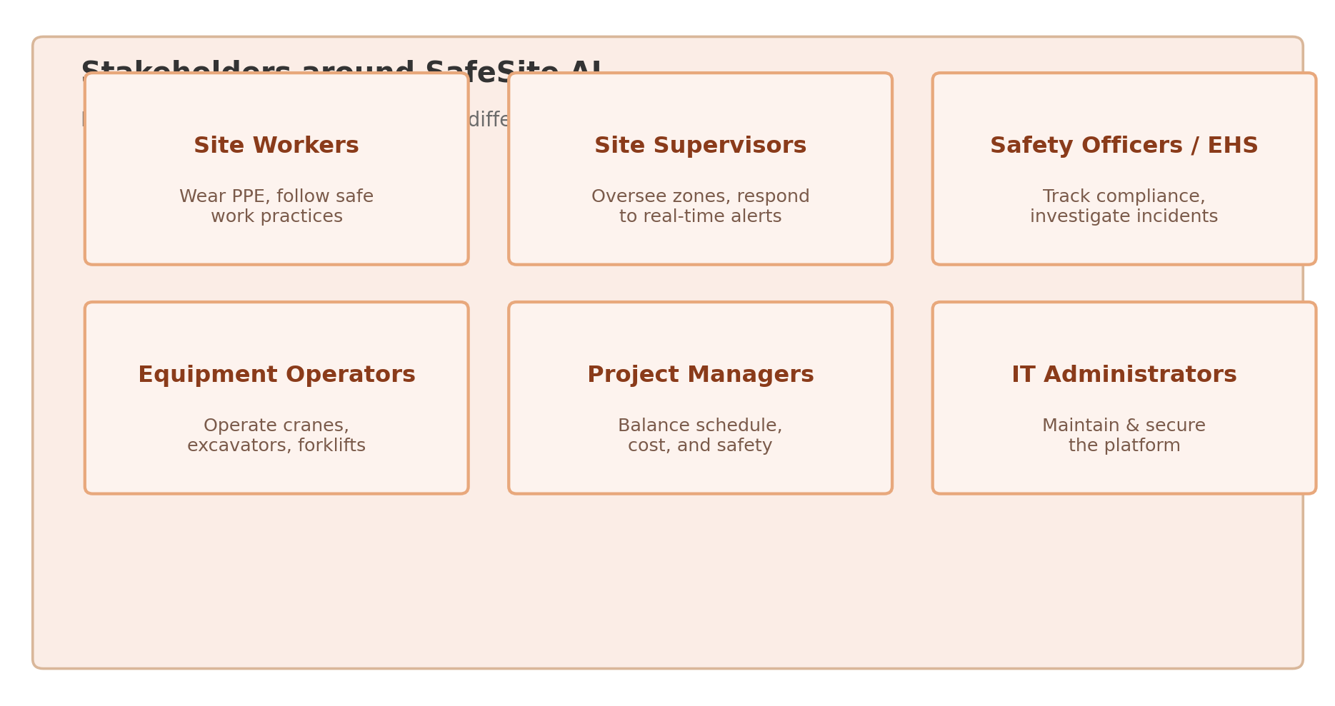
Figure 1: Stakeholder Ecosystem Diagram

3.1 Roles and Responsibilities
Stakeholder | Role | Responsibilities
Site Workers | Ground-level personnel | Wear required PPE, follow safe work practices, respond to alerts
Site Supervisors | Operations oversight | Monitor zones, respond to real-time alerts, enforce compliance
Safety Officers / EHS Teams | Compliance & investigation | Track PPE compliance, investigate incidents, prepare audit reports
Equipment Operators | Heavy machinery operation | Operate cranes, excavators, forklifts; heed proximity warnings
Project Managers | Schedule & cost control | Balance productivity with safety constraints, allocate resources
IT Administrators | Platform upkeep | Maintain integrations, enforce data security policy
Regulators / Auditors | Legal compliance verification | Review digitised, tamper-evident compliance records
Senior Management / Insurers | Budget, ROI, and risk | Approve investment, evaluate returns, assess project risk profiles

3.2 Major Challenges
- Information silos: video footage, equipment telemetry, and environmental data typically sit in separate systems, so no one stakeholder sees the full safety picture at once.
- Reactive operations: unsafe conditions (a missing hardhat, a worker inside a crane's swing radius) are usually discovered only after an incident or during a scheduled inspection, not before.
- Alert fatigue and false positives: a monitoring system that raises too many low-value alerts risks being ignored, undermining the very supervisors it is meant to support.
- Trust and adoption: workers accustomed to unsupervised routines may be reluctant to accept continuous camera and wearable-based monitoring unless the system's purpose and boundaries are explained transparently.

4. Analysis of the Current Approach

4.1 Existing System / Current Process
Most construction operators today rely on some combination of: scheduled manual safety walkthroughs performed by supervisors or safety officers; static CCTV systems that record footage for after-the-fact review rather than real-time analysis; paper or spreadsheet-based PPE and hazard checklists filled in periodically; and basic radio or phone-based communication for reporting hazards, which depends entirely on someone noticing and choosing to report.

4.2 Strengths
- Manual inspections benefit from human judgement and contextual understanding that automated systems can still struggle to replicate.
- CCTV systems are mature, reliable for record-keeping, and require little additional training for site staff.
- Low incremental cost, since basic cameras and radios are already standard on most sites.

4.3 Limitations
- No predictive capability — unsafe conditions surface only as near-misses or incidents, not as advance warnings.
- CCTV footage is reviewed reactively; it rarely prevents the incident it eventually helps explain.
- PPE compliance checking is manual and spot-based, missing violations that occur between inspection rounds.
- Equipment-proximity risk is judged by operator awareness alone, with no automated collision-risk warning.
- Safety data stays siloed across paper checklists, CCTV archives, and equipment logs, making cross-site trend analysis difficult.
- Reporting is retrospective (weekly/monthly), delaying corrective action until well after risk conditions have passed.

4.4 Gaps to Address
The core gap is the absence of an integrated, predictive safety-intelligence layer. Existing computer-vision research on construction sites confirms this shortfall directly: automatic, real-time detection of PPE non-compliance and unsafe worker behaviour remains an emerging capability rather than standard practice on most sites, precisely because it demands the kind of continuous, fused, multi-sensor analysis that manual inspection and static CCTV cannot provide. SafeSite AI closes this gap by unifying PPE detection, hazardous-zone monitoring, equipment-proximity tracking, and predictive risk scoring into a single real-time decision layer instead of several disconnected tools.

5. Proposed Software Solution

5.1 The Six Functional Modules
- IoT & Video Data Ingestion — collects camera streams, wearable telemetry, equipment sensor data, and environmental readings via MQTT/RTSP, buffered through a message queue (e.g., Kafka) for reliability during network fluctuation.
- PPE & Behaviour Detection (Computer Vision) — applies deep learning object-detection models to identify PPE presence/absence and unsafe postures in real time from video frames.
- Hazardous Zone & Equipment Proximity Monitoring — geofences restricted areas and tracks equipment-to-worker distance, flagging intrusions and collision risk.
- Predictive Risk Analytics — combines current detections with historical incident data to generate a dynamic risk score per zone, shift, or activity.
- Real-Time Alerting & Notification — delivers prioritised alerts to supervisors and safety officers via mobile push, SMS, dashboard, and on-site alarms/beacons.
- Compliance Dashboard & Reporting — compiles daily/weekly/project-level compliance reports and maintains a tamper-evident historical safety record.

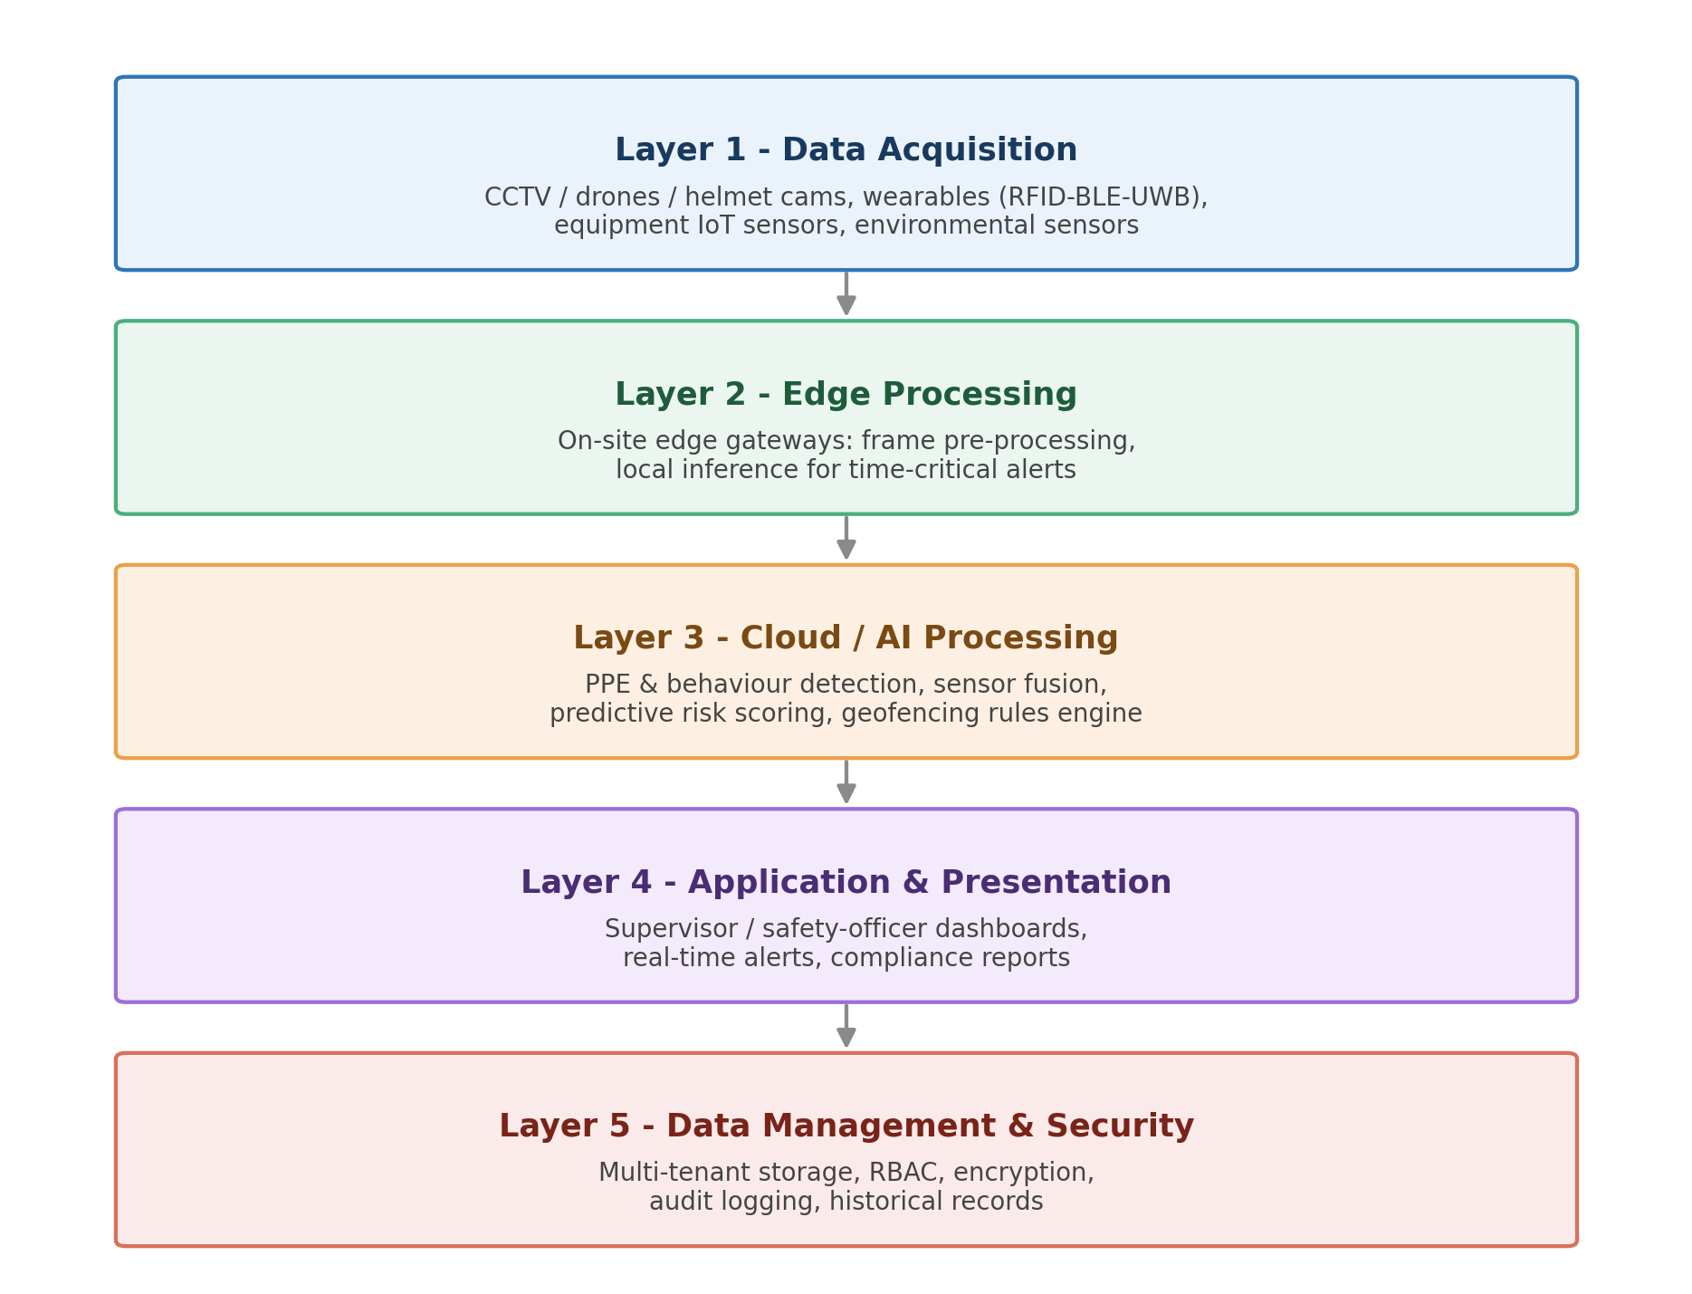
Figure 2: System Architecture Diagram
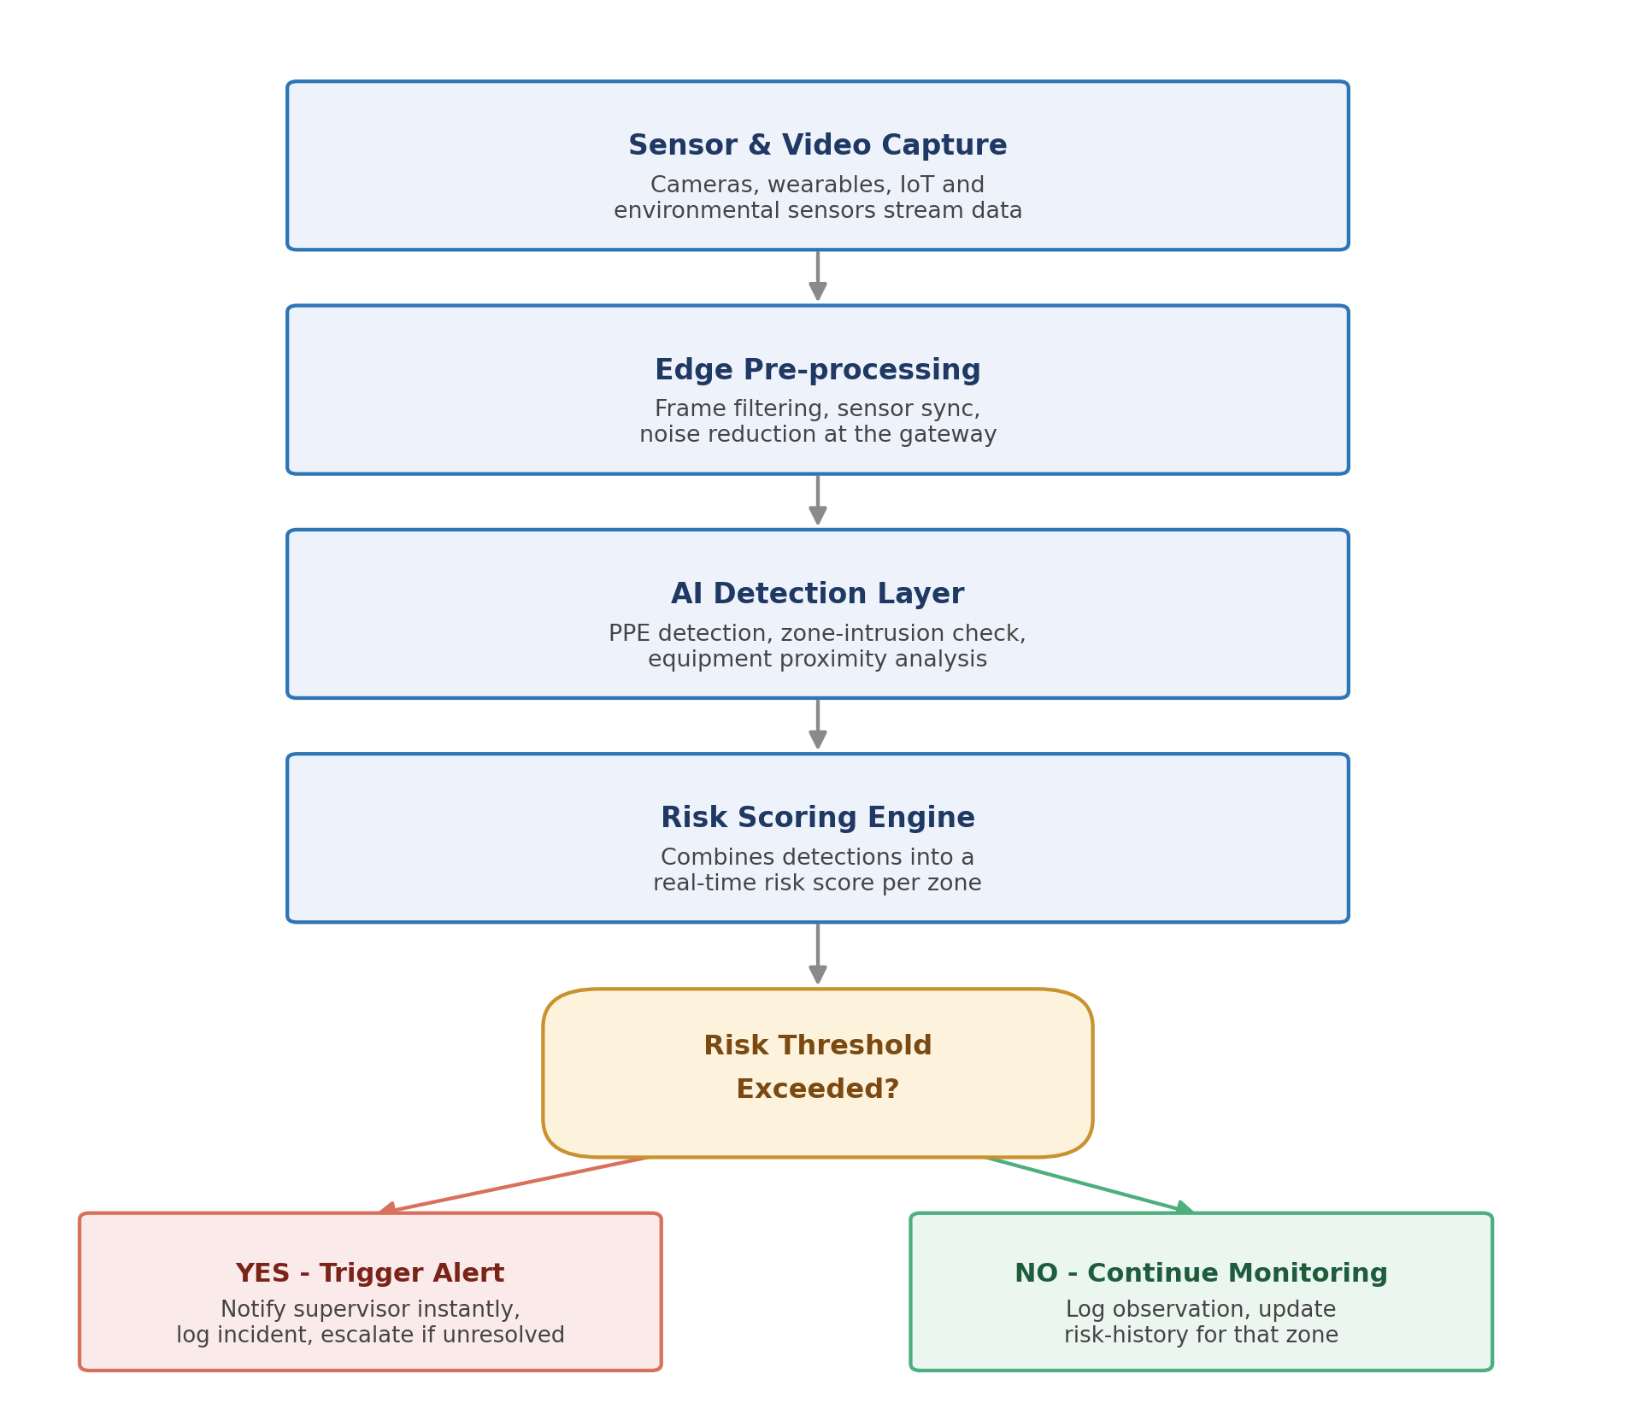
Figure 3: Real-Time Decision Flow Diagram

5.2 Functional Requirements
- Ingest and store real-time video and IoT sensor data from cameras, wearables, and equipment.
- Detect PPE compliance status per worker per frame and log violations against a worker/wearable ID.
- Detect hazardous-zone intrusion and equipment-proximity risk in real time.
- Generate a dynamic, per-zone predictive risk score and flag threshold breaches.
- Provide role-based dashboard access for supervisors, safety officers, and management.
- Send real-time alerts (PPE violation, zone intrusion, proximity risk, environmental threshold breach).
- Generate periodic and on-demand compliance reports for audits and regulators.

5.3 Non-Functional Requirements
- Performance: alert generation within 2–3 seconds of a detected unsafe condition.
- Scalability: support growth from a single pilot site to thousands of concurrent camera/sensor feeds across multiple projects without redesign.
- Reliability: 99.9% uptime target, with graceful degradation and local edge alerting on connectivity loss.
- Security: TLS encryption, role-based access control, secure API authentication, and anonymisation of biometric data where feasible.
- Usability: dashboard views intuitive enough for supervisors and safety officers with minimal training.
- Maintainability: modular microservices with clear separation of concerns, versioned APIs, and per-module test suites.
- Interoperability: standard APIs for integration with existing CCTV, telematics, and ERP/EHS systems.

5.4 Software Engineering Principles Applied
Modularity: each of the six modules is an independent microservice with well-defined APIs.
Scalability: containerised, cloud-native deployment (Docker/Kubernetes) with a message-queue ingestion layer absorbing bursts of video/IoT traffic.
Maintainability: clear separation of concerns, versioned APIs, and per-module automated test suites.
Reliability: redundant pipelines and rule-based fallback logic if ML-based detection is temporarily unavailable.
Usability: role-specific dashboard views tested with real supervisors and safety officers.
Security: encryption in transit and at rest, OAuth2 authentication, and full audit logging.

6. Supporting Mathematical Models

6.1 PPE Compliance & Violation Detection

1. PPE Compliance Rate
Formula
ComplianceRate (%) = (N_compliant / N_detected) × 100

Meaning
It measures what fraction of detected workers are wearing all required PPE at a given moment.
Where: N_compliant = workers detected wearing full required PPE; N_detected = total workers detected in frame.
Example
Workers detected = 50; workers fully compliant = 46
ComplianceRate = (46/50) × 100 = 92%

2. Detection Confidence Score
Formula
Confidence = P(class) × IoU(prediction, ground_truth)

Meaning
Combines the model's classification probability for a PPE item with how precisely the bounding box overlaps the true object location (Intersection over Union). A detection is only accepted as valid above a chosen confidence threshold (commonly 0.5).
Example
Classification probability = 0.93, IoU = 0.81
Confidence = 0.93 × 0.81 = 0.75 → accepted as a valid detection (threshold = 0.5)

3. Violation Severity Weight
Formula
Severity = w1(ExposureTime) + w2(HazardProximity) + w3(TaskRiskLevel)

Meaning
Quantifies how serious a given PPE violation is, based on how long the worker was exposed without protection, how close they were to an active hazard, and how dangerous the task itself is. Higher severity scores prioritise which violations get escalated first.
Example
ExposureTime = 40s (normalised 0.6), HazardProximity = 0.8, TaskRiskLevel = 0.7, weights w1=0.3, w2=0.4, w3=0.3
Severity = 0.3(0.6) + 0.4(0.8) + 0.3(0.7) = 0.71 (high-priority violation)

6.2 Predictive Accident Risk

1. Composite Zone Risk Score
Formula
RiskScore = w1(PPE_ViolationRate) + w2(ProximityRisk) + w3(EnvStressIndex) + w4(ZoneIncidentHistory)

Meaning
Combines four normalised (0–1) inputs — the PPE violation rate in a zone, equipment-proximity risk, an environmental stress index (heat, air quality, noise), and that zone's historical incident rate — into a single 0–100 risk score used to prioritise supervisor attention.
Example
PPE_ViolationRate = 0.2, ProximityRisk = 0.5, EnvStressIndex = 0.3, ZoneIncidentHistory = 0.4
Weights: w1=0.3, w2=0.3, w3=0.2, w4=0.2
RiskScore = (0.3×0.2 + 0.3×0.5 + 0.2×0.3 + 0.2×0.4) × 100 = 35 (moderate risk)

2. AI Prediction Model
Formula
RiskScore(t + Δt) = f(...)

Meaning
Instead of relying only on the current snapshot, a machine learning model (such as gradient boosting or an LSTM) predicts the near-future risk score using recent detection history, environmental trend data, equipment activity, and shift patterns — helping supervisors intervene before, not after, a threshold is crossed.

6.3 Equipment Proximity & Collision Risk

1. Worker–Equipment Distance
Formula
D = √[(x_e − x_w)² + (y_e − y_w)²]

Meaning
Calculates the straight-line distance between a worker's tracked position and a piece of equipment's tracked position, using coordinates from wearables/vision tracking and equipment GPS/IoT sensors.
Example
Worker at (12, 8), excavator at (16, 11)
D = √[(16−12)² + (11−8)²] = √(16+9) = 5 metres

2. Time-to-Collision (TTC)
Formula
TTC = D / V_relative

Meaning
Estimates how many seconds remain before a worker and a piece of moving equipment would collide if current paths and speeds continue. An alert is triggered when TTC drops below a safe threshold (e.g., 5 seconds).
Example
D = 5 m, relative closing speed = 2.5 m/s
TTC = 5 / 2.5 = 2 seconds → immediate alert triggered

3. Safe-Zone Constraint
Formula
Alert triggered if D < D_safe

Meaning
Defines a minimum safe distance (D_safe) around active equipment, such as a crane's swing radius; any worker position closer than this distance automatically raises a proximity alert regardless of TTC.

6.4 Safety KPI Formulas

1. Total Recordable Incident Rate (TRIR)
Formula
TRIR = (N_recordable × 200,000) / TotalHoursWorked

Meaning
A standard industry safety metric normalising recordable incidents to a base of 100 full-time workers (200,000 hours = 100 workers × 2,000 hours/year), allowing safety performance to be compared fairly across projects of different sizes.
Example
Recordable incidents = 3, total hours worked = 500,000
TRIR = (3 × 200,000) / 500,000 = 1.2

2. Near-Miss Ratio
Formula
NearMissRatio = NearMisses / (NearMisses + Incidents)

Meaning
Tracks how much of the platform's detected risk activity results in a near-miss (caught before harm) versus an actual incident — a rising ratio indicates the platform's preventive alerts are working.
Example
Near-misses = 18, incidents = 2
NearMissRatio = 18 / (18+2) = 0.9 (90% of risk events were caught before harm)

3. Alert Response Time
Formula
ResponseTime = Time_resolved − Time_issued

Meaning
Measures how quickly supervisors act on a safety alert once it is issued — a key operational KPI for evaluating whether the notification workflow is effective in practice.

7. Justification of Methodology/Framework

Recommended: Agile (Scrum) with DevOps/MLOps integration
Here's the development cycle visualized:
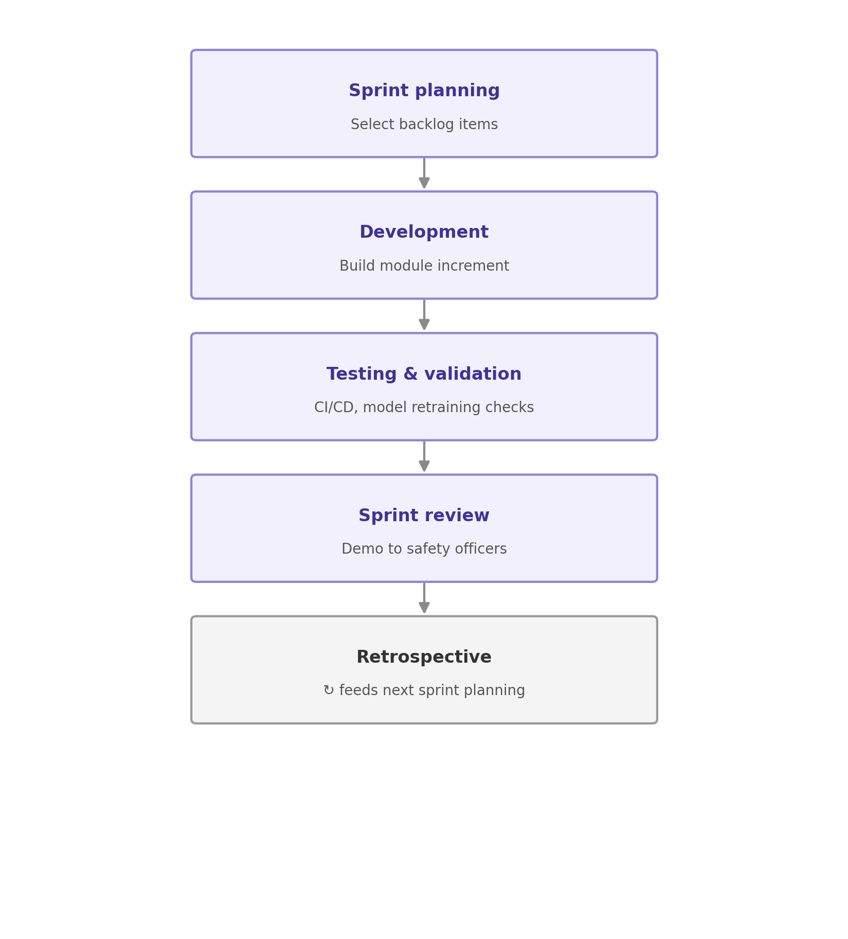
Figure 4: Agile Sprint Cycle Diagram

7.1 Why Agile/Scrum over Waterfall or Spiral
Evolving requirements: the PPE-detection and risk-scoring models need iterative tuning as real site imagery and incident data accumulate — a rigid Waterfall approach assumes fixed upfront requirements, which does not fit a system whose accuracy depends on continuous learning.
Stakeholder feedback loops: supervisors, safety officers, and workers need to give continuous input on alert usefulness and dashboard clarity; sprint reviews create a structured channel for this.
Incremental value delivery: the six modules can ship as separate increments (ingestion and dashboard first, then PPE detection, then zone/equipment monitoring, then predictive analytics), letting sites benefit before the full system is complete.
DevOps/MLOps integration: because the system depends on continuously retrained computer-vision and risk models plus live video/IoT streams, a CI/CD pipeline for code plus automated retraining/validation for models keeps detection accuracy high as site layouts, lighting conditions, and workforce composition change.

7.2 How It Supports Development and Maintenance
- Two-to-three-week sprints let computer vision modules be refined against growing site-specific footage rather than frozen at initial design.
- CI/CD reduces the risk of regressions when updating any single microservice.
- Regular sprint demos to safety officers build trust in AI-generated alerts, directly addressing the adoption-resistance challenge identified in Section 3.
- A product backlog lets new requirements (a new camera type, a new PPE category, a new regulatory reporting format) be absorbed without a full re-planning cycle.

8. Expected Outcomes and Limitations

8.1 Expected Benefits
- Fewer workplace accidents through real-time detection and predictive risk alerts.
- Stronger, continuously documented regulatory compliance.
- Reduced insurance costs through demonstrable, data-backed risk reduction.
- Improved project efficiency, with fewer accident-related stoppages and delays.
- Faster, better-informed safety decisions for supervisors and safety officers.
- Greater operational transparency across multiple concurrent projects.

8.2 How the Solution Addresses Identified Challenges
- Removes data silos by unifying video, wearable, equipment, and environmental data into one platform.
- Converts safety management from reactive to proactive through predictive, real-time alerts.
- Reduces alert fatigue through severity-weighted, prioritised notifications rather than raw detection dumps.
- Builds worker and supervisor trust through transparent, explainable alerts tied to specific, visible conditions.

8.3 Risks, Implementation Challenges, and Limitations
- Data quality dependency: detection accuracy depends on camera coverage and sensor completeness; poor lighting, dust, or occlusion degrades model performance.
- Integration complexity: inconsistent formats across existing CCTV and telematics hardware complicate ingestion.
- Model drift: PPE-detection and risk models need continuous retraining as site layouts and workforce patterns change; without sustained MLOps investment, accuracy decays.
- Adoption resistance: workers may perceive continuous monitoring as surveillance unless policies and purpose are communicated transparently.
- Environmental hardware stress: dust, vibration, and weather can affect camera/sensor reliability on active sites.
- Upfront cost: retrofitting older sites with cameras, wearables, and connectivity requires initial investment.

8.4 Future Enhancements
- Drone-based aerial monitoring for large or hard-to-cover sites.
- Voice/text-based natural-language querying of safety dashboards for supervisors.
- Integration with wearable biometric sensors for heat-stress and fatigue detection.
- Automated incident root-cause analysis using historical video and sensor replay.
- Predictive maintenance extended to equipment health, not just worker safety.

9. Conclusion
SafeSite AI addresses a structural gap in current construction safety management: the absence of a single platform that connects worker behaviour, PPE compliance, equipment movement, and environmental conditions through continuous, predictive intelligence rather than treating them as separate, manually-inspected concerns. By combining computer vision, IoT-based real-time monitoring, predictive risk scoring, and a modular, Agile-developed architecture, the platform is positioned to reduce workplace accidents, strengthen regulatory compliance, and support measurable improvements in operational transparency across multiple construction projects.
Its success, however, is conditional — it depends on adequate camera/sensor coverage, ongoing model retraining, and genuine worker and supervisor trust in AI-driven alerts. These are manageable risks with the right MLOps discipline and change-management approach, making SafeSite AI a technically sound and commercially justifiable investment for construction companies seeking to move from reactive safety documentation to proactive accident prevention.

References
1. Delhi, V. S. K., Sankarlal, R., & Thomas, A. (2020). Detection of Personal Protective Equipment (PPE) Compliance on Construction Site Using Computer Vision Based Deep Learning Techniques. Frontiers in Built Environment, 6, 136.
2. Fang, Q., Li, H., Luo, X., Ding, L., Luo, H., Rose, T. M., & An, W. (2018). Detecting Non-Hardhat-Use by a Deep Learning Method from Far-Field Surveillance Videos. Automation in Construction, 85, 1–9.

